

**KULLIYYAH OF INFORMATION AND COMMUNICATION TECHNOLOGY**

**DEPARTMENT OF INFORMATION SYSTEMS**

**INFO 2302 - WEB TECHNOLOGIES**

**PROJECT NAME: MARHABAN CAFE’**

**PROJECT REPORT**

**GROUP MEMBERS**

|  |  |
| --- | --- |
| Member’s Name | Matric No. |
| BAWAZIR ABDURRAHMAN ALI | 1828549 |
| HASAN AL MAMUN | 1820613 |
| NUR AFIQAH BINTI MOHD ROSLI | 1910100 |
| NURHARITH AKMA BINTI HARSIA | 1910110 |

**CLASS : SECTION 3, SEMESTER 1 2020/2021**

**1.Project Description:**

We have developed a website for a restaurant to help the business operation. The website’s name is Marhaban Cafe’. This website provides necessary information regarding the restaurant services and operation. Besides that, it contains the function for customers to place their order and also place their feedback after purchasing our product. So we will be able to review it back later and improve our service in future.

**Our project objectives are:-**

1. To ease the customer to place their order.
2. To promote the restaurant brand image and product online.
3. To keep the customers informed regarding our business such as location, operation time and the menu.

**Modules:-**

1. Home

This section has a header , logo of the website, some information and footer that contains contact information such as location, phone number, email and operation hours.

1. About Us

This page contains information about our team and the business that provides an idea to the customer of what our restaurant is all about and what we do.

1. Menu

This is the food and beverages section. Customers can view all the menu and place order as their preference.

d. Order

Here the customers’ choice will appear as they make their order. This page will also appear automatically when customers click the images in the menu page.

e. Feedback

This page contains the feedback form for the customer's review.

f. Sign Up

This page contains the registration form for customers to sign up.

**2.Project Sitemap:**

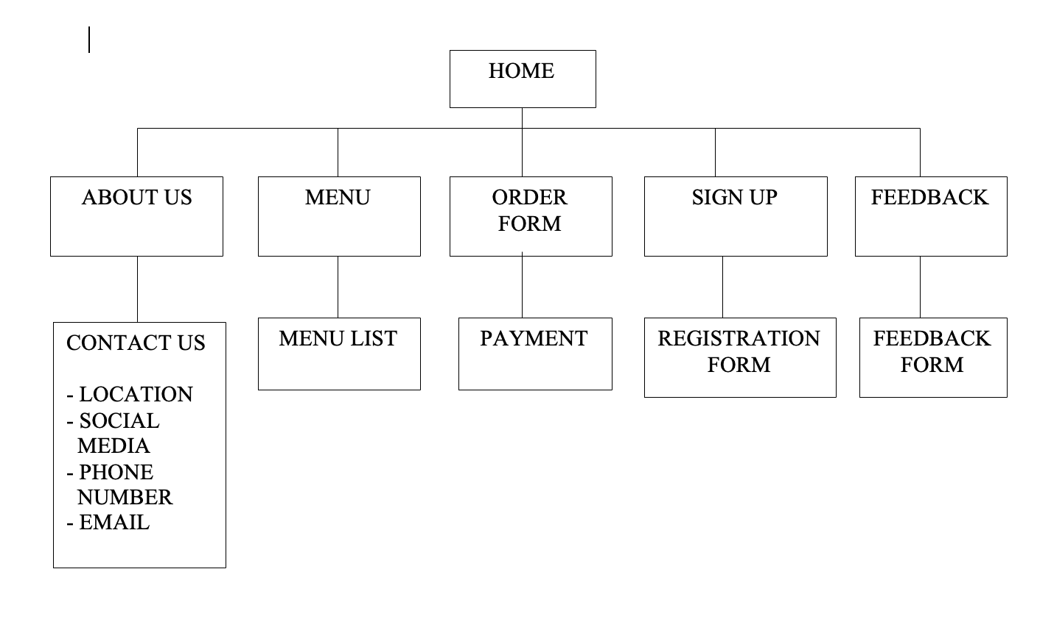

**3. Group Contribution**

|  |  |
| --- | --- |
| **Name & Matric No** | **Contributions** |
| Hasan Al Mamun  (1820613) | * Pages: Home Page including header, footer, Contact Info with embedded Google Map API. * Order Page using Javascript |
| Abdurrahman Ali Bawazir  (1828549) | * Pages: Menu * Added foods and beverages pictures with styling and also make div class= vid ,inside it there is an iframe function to add youtube video on the bottom of the page which is autoplaying when the user opens that page. |
| Nurharith Akma binti Harisa  (1910110) | * Pages: Feedback and Sign Up * Web elements : Logo * Create two forms with validation in two ways. First using Javascript and the other one using automatic HTML form validation. |
| Nur Afiqah Bt Mohd Rosli  (1910100) | * Page: About us * Web elements : logo and photos * Added groupmate's pictures with appropriate styling and JQueryUI for the slideshow as well as description of the restaurant.. |

**4. Use of Third Party Resource**

|  |  |  |  |
| --- | --- | --- | --- |
| Web Elements | Name | Use third party resources and modification(if any) | Modification (if any) |
| Fonts | Akma  Mamun | Font type Montserrat are used in styling the form font.  <https://fonts.googleapis.com/css?family=Montserrat:400,700&display=swap> | - |
| Photos for slideshow | Afiqah | Pexels.com  <https://www.pexels.com/search/restaurant/> | All picture resized by cropping some area |
| Slideshow | Afiqah | Code is used from fotorama website  <https://fotorama.io/> | **-** |
| Food photo | Mamun | <https://www.google.com/search?q=arabian+kabsa+chicken&tbm=isch&ved=2ahUKEwip-bfFqYrxAhVKlUsFHSFJDmUQ2-cCegQIABAA&oq=arabian> |  |

**5. References**

1. Form validation. Retrieved 25 May from <https://www.w3schools.com/js/js_validation.asp>

